Lab Assignment-9

Indian Institute of Technology Roorkee Department of Computer Science and Engineering

CSN-361: Computer Networks Laboratory (Autumn 2019-2020)

Aman jaiswal
Enrollment No:-17114008
B.tech CSE 3rd Year.

Problem Statement 1:
Install Wireshark and explore its uses to capture network traffic. You have to capture normal internet traffic for 20-30 minutes from your system using Wireshark. You need to copy this data in CSV / TXT file.

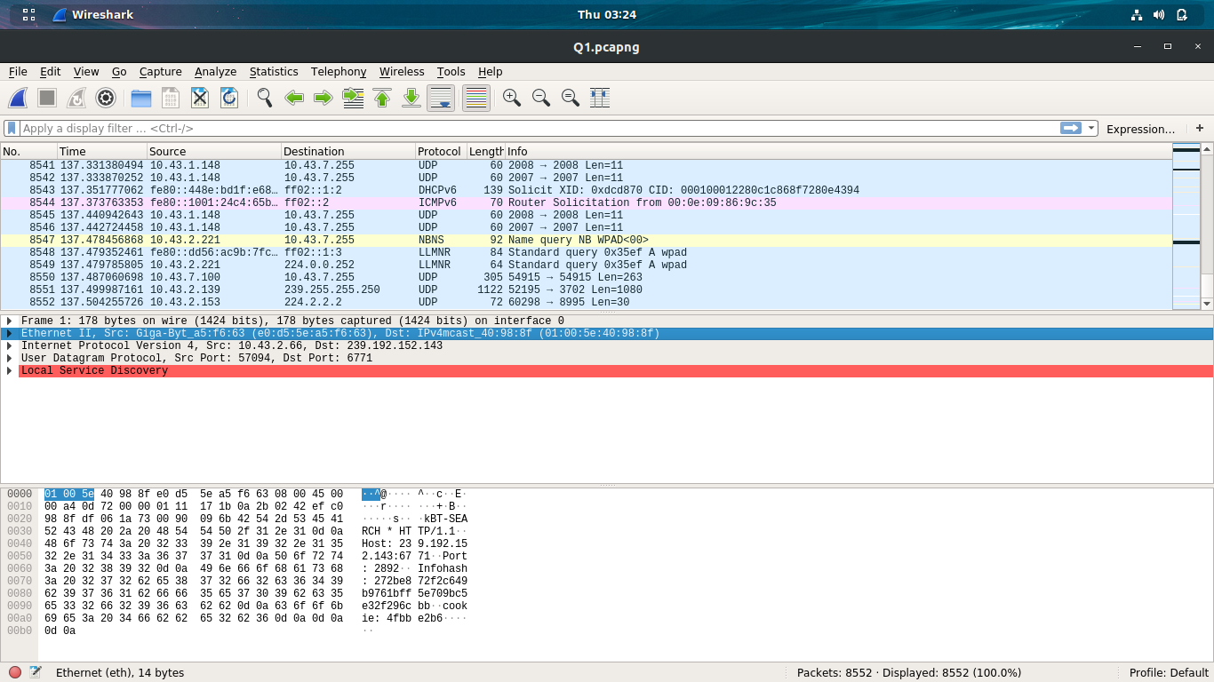

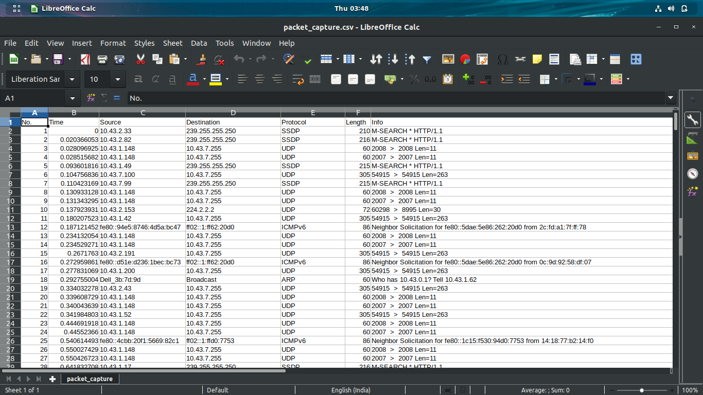

Problem Statement 2:
Take the CSV / TXT, which is generated in Problem Statement 1 as an input. Write a code (in any programming language of your choice) to extract the following 11 features given below in the table:

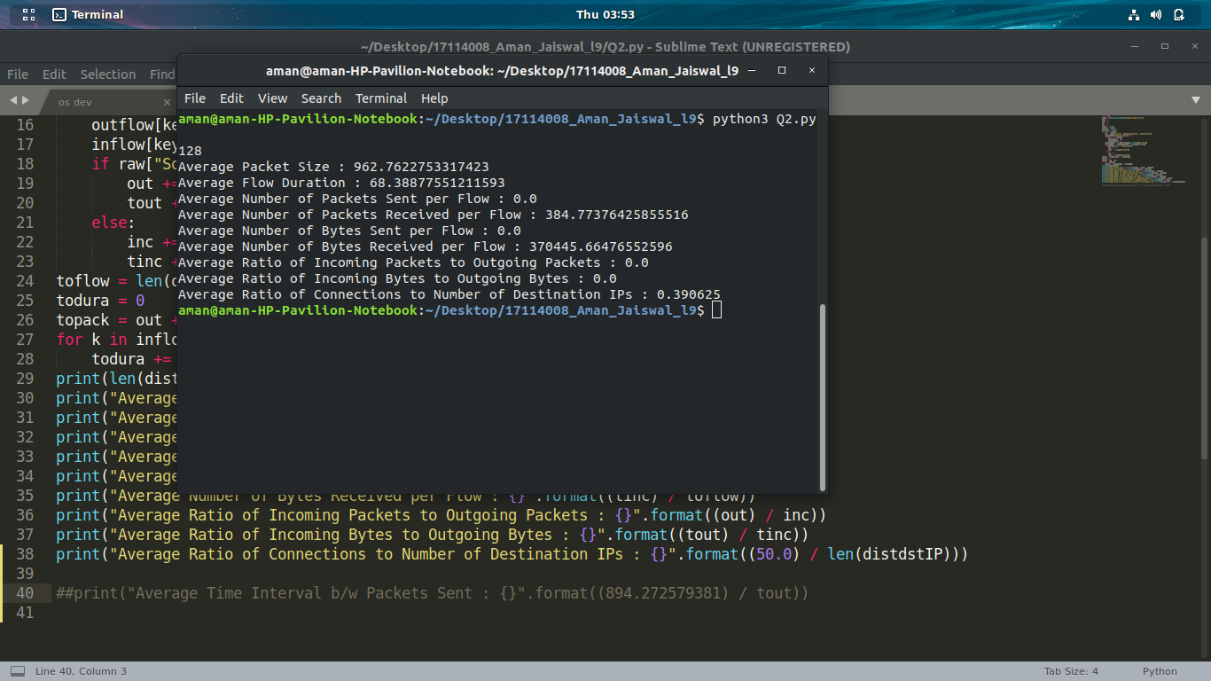

Problem Statement 3:
In this problem, the behavior of TCP protocol will be studied using Wireshark. For this assignment download the Wireshark captured trace file named as tcpethe-trace from Piazza,which is a packet trace of TCP transfer of a file from a client system to a remote server (named as ser1), obtained by running Wireshark on the client machine. Open tcpethe-trace file in Wireshark and answer the following question:

a. What is the IP address and TCP port number used by the client computer (source) that is transferring the file to server (ser1)?

Sol->
The client computer (source)’s IP address is 192.168.1.102 and the TCP port number is 1161.

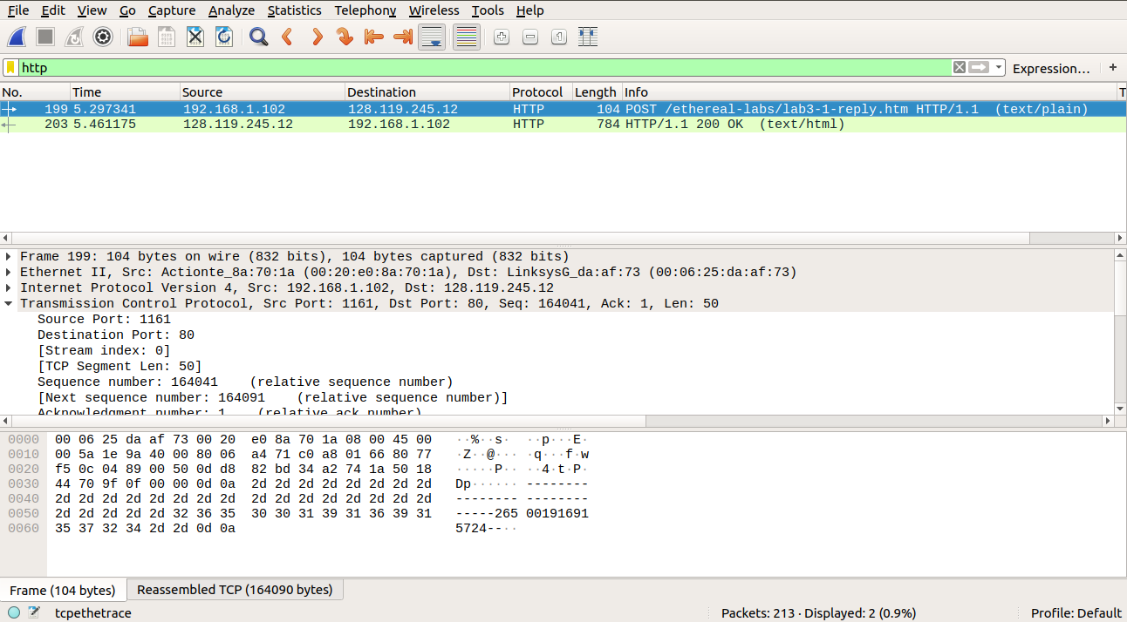

b. What is the IP address of server (ser1)? On what port number it is sending and receiving the TCP segments for this connection?

Sol-> The IP address of ser1 is 128.119.245.12 and the TCP port number is 80.
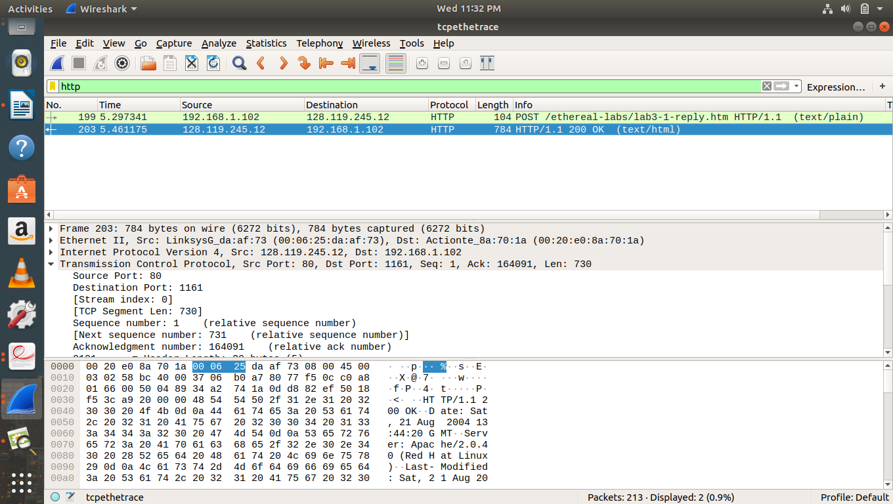
c. What is the sequence number of the TCP SYN segment that is used to initiate the TCP connection between the client computer and ser1? What is it in the segment that identifies the segment as a SYN segment?

Sol-> The sequence number of the TCP SYN segment is 0 since it is used to imitate the TCP connection between the client computer and ser1.
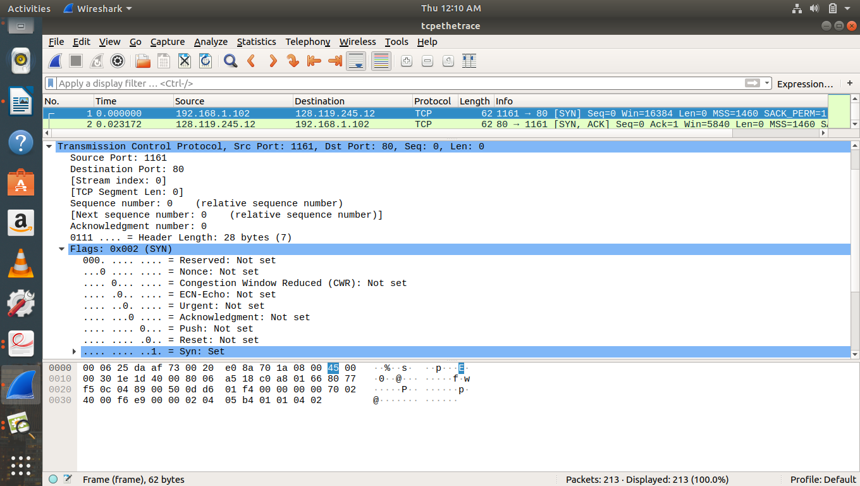
In the Flags section, the Syn flag is set to 1 which indicates that this segment is a SYN segment.

d. What is the sequence number of the SYNACK segment sent by ser1 to the client
computer in reply to the SYN? What is the value of the Acknowledgement field in the
SYNACK segment? How did ser1 determine that value? What is it in the segment that
identifies the segment as a SYNACK segment?

Sol-> The sequence number of the SYNACK segment sent by ser1 to the client computer in reply to the SYN is 0.
The value of the acknowledgement field in the SYNACK segment is 1. The value of the
ACKnowledgement field in the SYNACK segment is determined by the server ser1
The server adds 1 to the initial sequence number of SYN segment form the client computer. For this case, the initial sequence number of SYN segment from the client computer is 0, thus the value of the ACKnowledgement field in the SYNACK segment is 1.
A segment will be identified as a SYNACK segment if both SYN flag and Acknowledgement in the segment are set to 1.
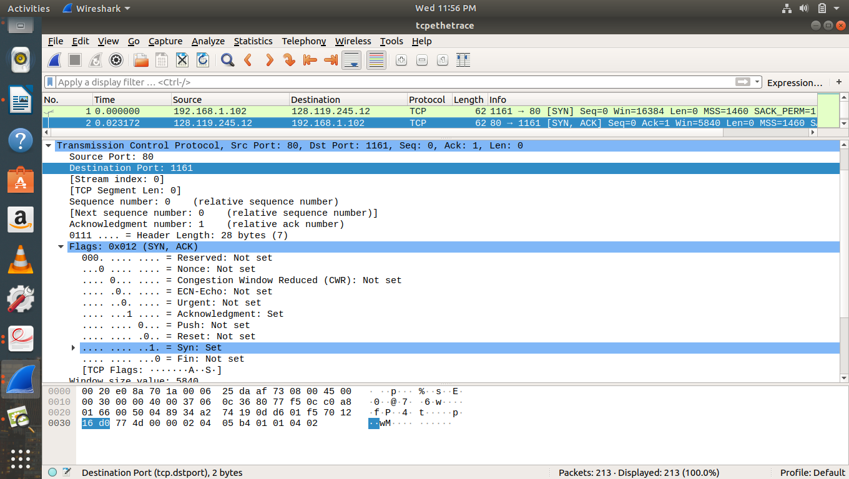

e. What is the sequence number of the TCP segment containing the HTTP POST
command? Note that in order to find the POST command; you’ll need to dig into the
packet content field at the bottom of the Wireshark window, looking for a segment with a “POST” within its DATA field.

Sol-> The segment No. 4 contains the HTTP POST command, the sequence
number of this segment is 1.
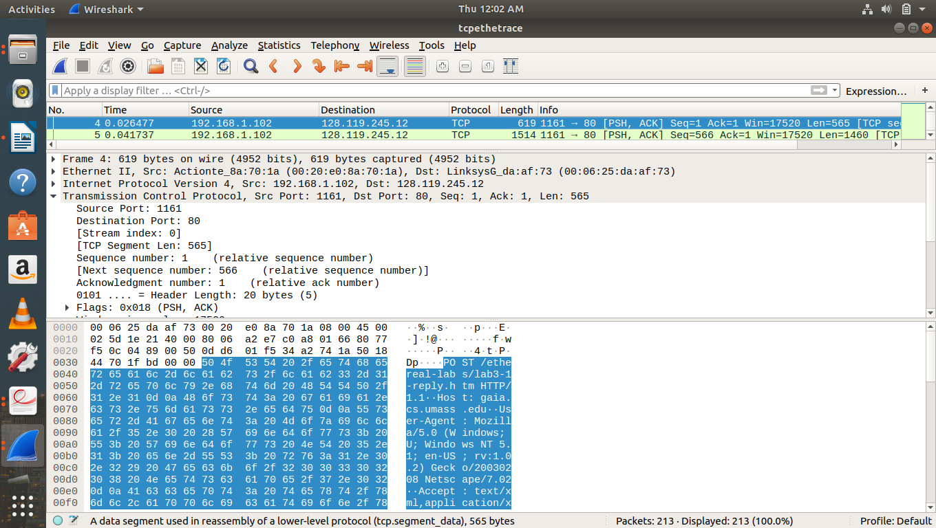

f. Consider the TCP segment containing the HTTP POST as the first segment in the TCP connection. What are the sequence numbers of the first six segments in the TCP
connection (including the segment containing the HTTP POST)? At what time was each segment sent? When was the ACK for each segment received? Given the difference between when each TCP segment was sent, and when its acknowledgement was received, what is the Round Trip Time (RTT) value for each of the six segments? What is the Estimated RTT value after the receipt of each ACK? Assume that the value of the Estimated RTT is equal to the measured RTT for the first segment, and then is computed using the following Estimated RTT equation for all subsequent segments.
Estimated RTT = (1 – α) * Estimated RTT + α * SampleRTT
where, the new value of Estimated RTT is a weighted combination of the previous value of Estimated RTT and the new value for SampleRTT. The recommended value of α = 0.125.

Sol->
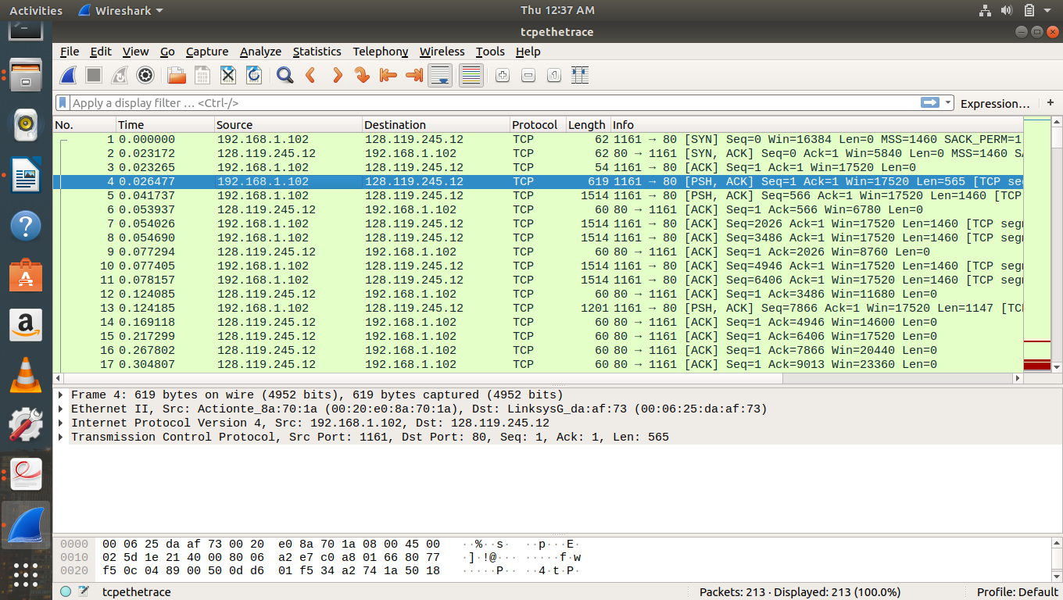
According to above figures, the segments 1-6 are No. 4, 5, 7, 8, 10 and 11. The ACK of segments 1-6 are No. 6, 9, 12, 14, 15 and 16.
Segment 1 sequence number is 1
Segment 2 sequence number is 566
Segment 3 sequence number is 2026
Segment 4 sequence number is 3486
Segment 5 sequence number is 4946
Segment 6 sequence number is 6406

 | Sent time | ACK received time | RTT
Segment 1 | 0.026477 | 0.053937 | 0.02746
Segment 2 | 0.041737 | 0.077294 | 0.035557
Segment 3 | 0.054026 | 0.124085 | 0.070059
Segment 4 | 0.054690 | 0.169118 | 0.11443
Segment 5 | 0.077405 | 0.217299 | 0.13989
Segment 6 | 0.078157 | 0.267802 | 0.18964

EstimatedRTT = 0.875 * EstimatedRTT + 0.125 * SampleRTT

EstimatedRTT after the receipt of the ACK of segment 1:
EstimatedRTT = RTT for Segment 1 = 0.02746 s

EstimatedRTT after the receipt of the ACK of segment 2:
EstimatedRTT = 0.875 * 0.02746 + 0.125 * 0.035557 = 0.0285 s

EstimatedRTT after the receipt of the ACK of segment 3:
EstimatedRTT = 0.875 * 0.0285 + 0.125 * 0.070059 = 0.0337 s

EstimatedRTT after the receipt of the ACK of segment 4:
EstimatedRTT = 0.875 * 0.0337+ 0.125 * 0.11443 = 0.0438 s

EstimatedRTT after the receipt of the ACK of segment 5:
EstimatedRTT = 0.875 * 0.0438 + 0.125 * 0.13989 = 0.0558 s

EstimatedRTT after the receipt of the ACK of segment 6:
EstimatedRTT = 0.875 * 0.0558 + 0.125 * 0.18964 = 0.0725 s

g. What is the length of each of the first six TCP segments?

Length of the first TCP segment (containing the HTTP POST): 565 bytes
Length of each of the other five TCP segments: 1460 bytes
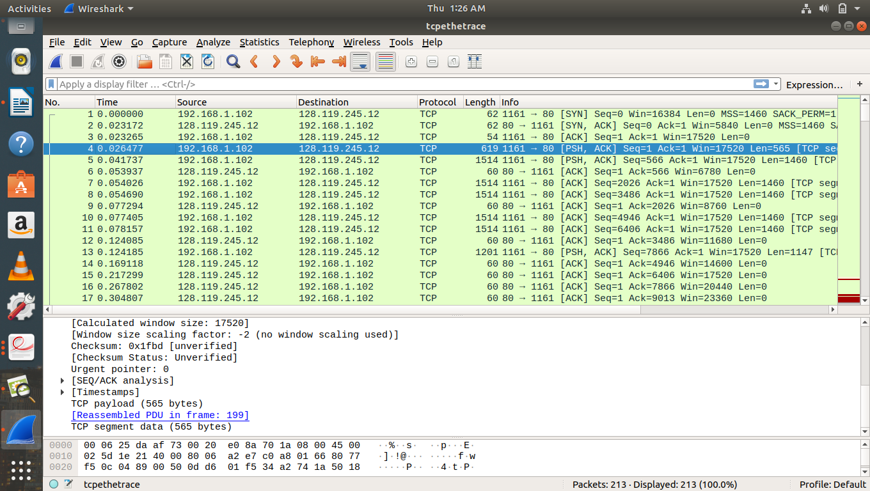
h. What is the minimum amount of available buffer space advertised at the received for the entire trace? Does the lack of receiver buffer space ever throttle the sender?

The minimum amount of buffer space (receiver window) advertised at
ser1 for the entire trace is 17520 bytes, which shows in the first acknowledgement from the server. This receiver window grows steadily until a maximum receiver buffer size of 62780 bytes. The sender is never throttled due to lacking of receiver buffer space by inspecting this trace.
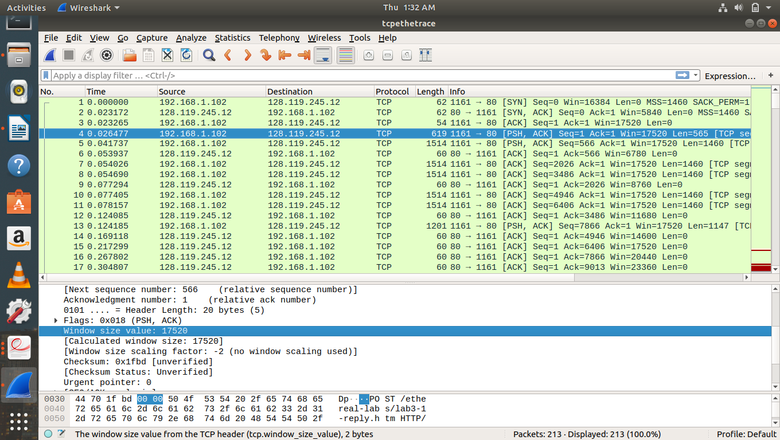

i. What is the throughput (bytes transferred per unit time) for the TCP connection? Explain how you calculated this value.

The computation of TCP throughput largely depends on the selection of
averaging time period. As a common throughput computation, in this question, we select
the average time period as the whole connection time. Then, the average throughput for
this TCP connection is computed as the ratio between the total amount data and the total
transmission time. The total amount data transmitted can be computed by the difference
between the sequence number of the first TCP segment (i.e. 1 byte for No. 4 segment)
and the acknowledged sequence number of the last ACK (164091 bytes for No. 202
segment). Therefore, the total data are 164091 - 1 = 164090 bytes. The whole
transmission time is the difference of the time instant of the first TCP segment (i.e.,
0.026477 second for No.4 segment) and the time instant of the last ACK (i.e., 5.455830
second for No. 202 segment). Therefore, the total transmission time is 5.455830 -
0.026477 = 5.4294 seconds. Hence, the throughput for the TCP connection is computed
as 164090/5.4294 = 30.222 Kbyte/sec
